**Day 3 Morning Assignment Answers (26-1-2022)**

Q1). Write the differences between while and do while loop.

A) While :

While(condition)

{

Statements;

}

* In while, if the condition satisfies then only the loop/statements will execute.

Do-While :

Do

{

Statements;

}

While(Condition)

* In Do-while , first the loop/statements will execute once, then after it will check for condition, if the condition satisfies, the statements will execute again.

2. Write simple C# code from notepad and compile it using csc

put the screen shot.

2A)

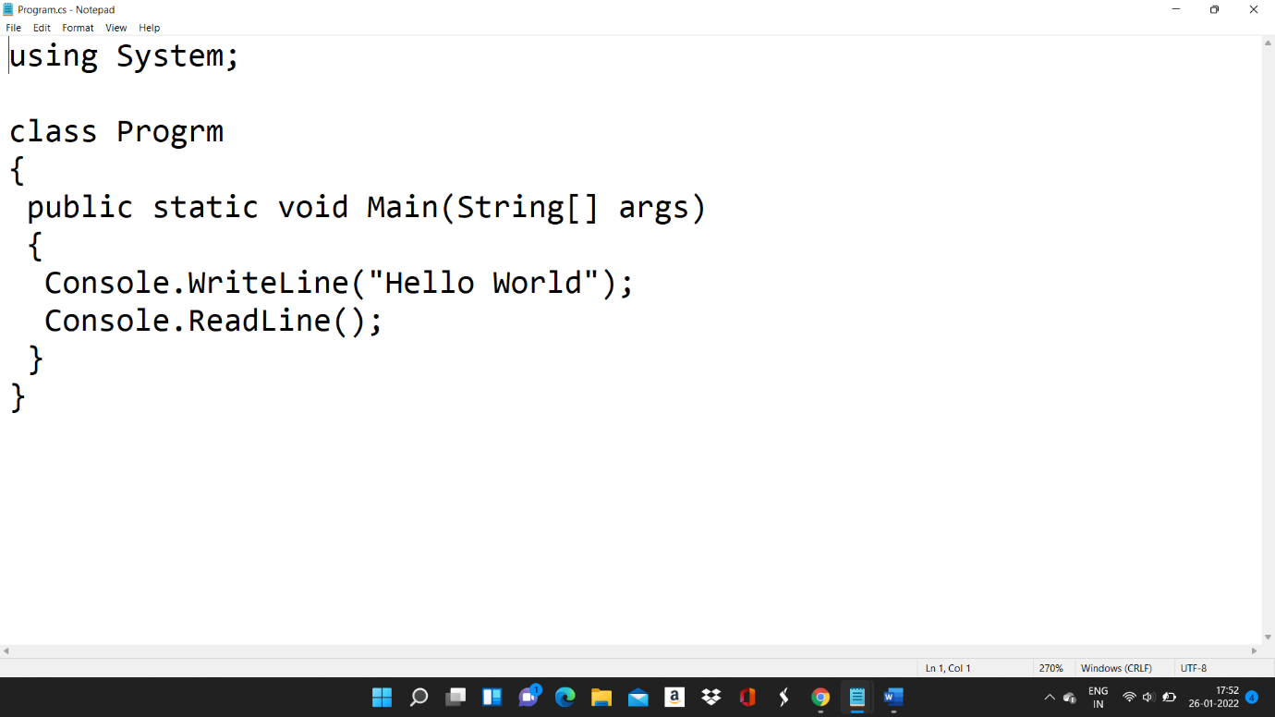

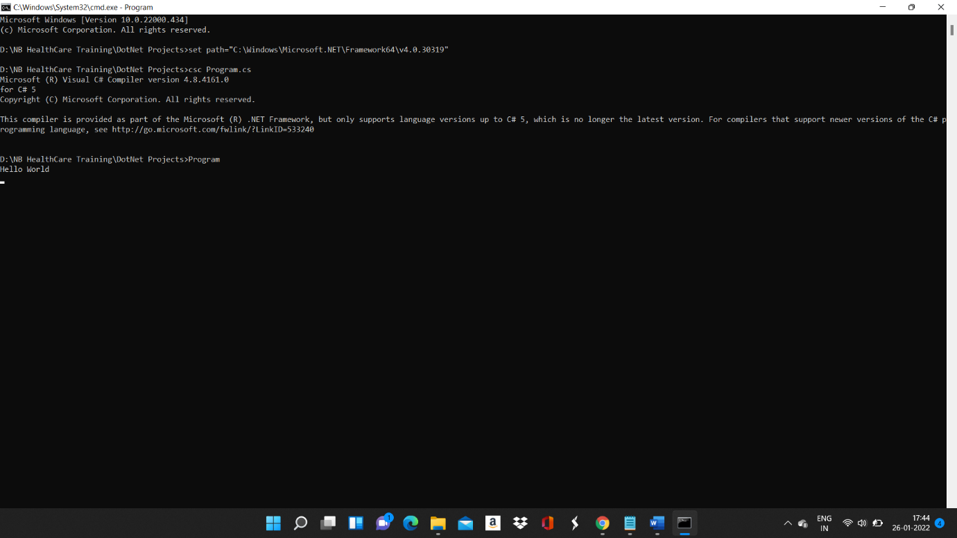

6. Write the 6 points about arrays discussed in the class.

A)

1. Arrays are Collection of Similar Data Types

2. Array size cannot be increased dynamically

3. Array index starts from Zero

4. Array Variable Size = Array Length x Data Type Size

5.Arrays Require Sequential Memory Location

6.When you are initialising the array with some values , you don’t have to mention the size.(because you are indirectly saying the size).